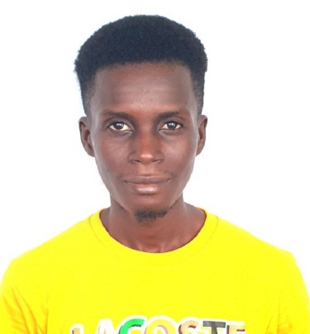
CURRICULUM VITAE
MOHAMED AFLFRED FODAY MANSARAY
Address: 163 Hanga Road Jui Talaban – Freetown
Contact: +23208 185 170/+23232 381 774
Email: mansaraymohamedaf@gmail.com

PERSONAL INFORMATION
DATE OF BIRTH: 8th August, 1995
PLACE OF BIRTH: Jui OSD Barracks Freetown
NATIONALITY: Sierra Leonean
MARITAL STATUS: Married
SEX: Male
RELIGION: Christian
HOBBY: Reading and Listing to News

EDUCATIONAL BACKGROUND
YEAR | INSTITUTION | QUALIFICATION
2015 | Allawalie Computer Training School | Certificate in Microsoft Application Package
2015 | Future learn online studies, Ireland | Diploma in Humanitarian Aid
2017 | Murialdo | Certificate in Informatics and Computer Basic
2018 | Blue Crest College | High National Diploma Computer Science
2019 | Alison online studies | Certificate in Coronavirus what you need to know
2020 | Future learn online studies | Data Base Management System (Awaiting)
2012 | Baptist Senior Secondary School | West Africa Senior School  Certificate Examination (WASSCE)
2015 | War Wounded Academy Senior Secondary School | West Africa Senior School  Certificate Examination (WASSCE)
2009 | Huntingdon Junior Secondary School | Basic Education Certificate Examination (BECE)

WORKING EXPRENCE
YEAR | INSTITUTION | POSITION
2012 | National Electoral Commission (NEC) | Pooling Staff (PS)
2015 | Steeping Stone (NGO) | Office Assistant
Dec 2017 | National Electoral Commission (NEC) Local  Headman Election | Ballot Box Controller (BBC)
2018 | Alhaji Bah internet Cafe | Data Clerk
2020 | Omega Venture Computer Training School | Data Entering Clerk
2021 | White Dove Computers | Typist

CAREER OBJECTIVE
A self-motivated and dedicated man looking forward to serve humanity and acquire experience, exposure and personal growth and having the ability to influence social change and development in my place of work and serving my community.

An enthusiastic and well organized individual, possess good administrative skills with a sound knowledge on Microsoft Office. Work as part time or full time of a team, able to cope with a varied workload under pressure. Ability to prioritize and organized worked. Able to motivate and support staff to meet the client’s need and dedicated to maintaining high quality assurance standards.

I am committed, friendly and hardworking person with a passion for providing excellent services at all times. I am articulate person who relishes challenges and working under pressure with little supervision. My greatest strengths are my typing skills, Data entry, researches, communication, writing skills and communication
I am talented, ambitious and hardworking individual with broad skills and experience in Software, Word, Power Point and Excel in Computer and also leading projects.

PERSONAL SKILLS
- Team work
- Very strong interpersonal skills with ability to gain trust and respect others.
- Being sensitive to others people’s needs and feelings, and enjoying to build and bonding of terms.
- Ability to work under pressure and tension with minimal supervision.
- Good oral communication.
- Moderate level of presentation.
- Planning, organizing, implementing and training techniques
- Ability to work in a multi-cultural environment, honest hardworking
- Very punctual and time conscious
- Ability to take own initiative
- A motivated and ambitions individual always ready to learn and who can maintain a professional experience at all time
- An individual who can maintain confidentiality and discretion, have a capacity to withstand pressure and an ability to go extra miles when the need arise.
SKILLS
- Confident outlook. - Typing skills - MS word
- Punctual and well presented - Data Entry
- Good to work individual or team - Attention to details
- Open minded and non – judgmental - Problem solving
- Enjoying a competitive environment - Can Ride (Moto Biek)
- Flexible, open to idea and willing to learn
- Ensure high levels of customer satisfaction

REFEREES

- MR. IBUKUN A. AYODELE
White Dove Computers
General Manager & CEO
49 Waterloo Highway, Jui.
Contact: +23276-552-245
Email: whitedovecomputers01@gmail.com

- REV. RAYMOND AMARA
Vicar
St. Thomas Church, Grafton
Anglican Diocese of Freetown
Part Time Lecturer (College of Theology & Management and Church Training Centre, Wesley Street Freetown)
Contact: +23277-472-592/ +23275-331-476
Email: amararaymond17@gmail.com

