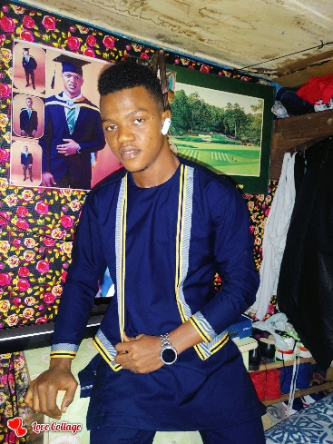
YUSIF IDRISSA KAMARA
5 Jalloh Street Rokupa, Wellington -Freetown
Sierra Leone.
Email Address: kamarayusifidrissa@gmail.com
Date of Birth: 17 September 1998
Marital Status: single
Mobile : +23299216413

Career profile:

As a Gender expert I have successfully managed relationships and restored hope and confidence in the lives of many including the marginalised, hopeless categories in time of shocks and stress strengthened relationship with families sometimes in a complex, diverse, and challenging environment. Also have a proven track record of financial management and compliance in managing resources including groups I have served. I have an in-depth understanding of Sierra Leone’s socio-economic and political environment and its development trajectory. Proven experience of working in a multicultural setting with respect for diversity; team player with the ability to work independently and under pressure; well organised, compliant, result oriented, reliable, and efficient. I have an appreciable local travelling experience within Sierra Leone positioning me to work in multi-national environment with effectiveness and efficiency. Self-motivated and compassionate individual and a Graduate with B.A in Gender and Development Studies and have vast experience in collecting data, analysing and proffering solution on gender and related fields, such as Child protection, Human trafficking and policy formulation on gender. Applying theories into practices, excellent communication and interpersonal Skill with an exceptional skill in negotiating, Advising and with Basic ICT skill.

EDUCATION

Fourah Bay College University of Sierra Leone 2018 - 2021
B.A Gender and Development studies

SENIOR SECONDARY SCHOOL
Sierra Leone Muslim Congress 2014 - 2017
West Africa Senior School Certificate Examination

Junior Secondary School
Sierra Leone Muslim Congress
Basic Education Certificate Examination 2011 - 2013

Primary school 2005 - 2010
Sierra Leone Muslim Commission
National Primary School Examination

EXPERIENCE
STATISTICS SIERRA LEONE
Enumerator Officer December 2021

Responsibilities
- List all structure, household and enumerate all persons in my enumeration area
- Run the report on my tablet and correct any error
- Administer questionnaire to every household in my enumeration area
- Sink all data to headquarter vie the supervisor
- Complete the work in the stipulated time and handover all logistics in an orderly manner
- Take instruction from headquarter vie the Supervisor

INTERNSHIP PROJECT
Internship student at Girl Child Network - S/L Aug – Sep 2021

Responsibilities:
- Teach Adolescence on Sexual Reproductive Health Lessons in Primary and Secondary Schools
- Facilitation on menstrual hygiene management with adolescent boys and girls, together with their teachers.
- Data collection on menstrual hygiene management at primary, junior and senior secondary schools at western area.
- Engage principals on the importance of menstrual hygiene management before the workshop.

NATIONAL CIVIL REGISTRATION AUTHORITY (NCRA) May-Jun - 2017
Data Entering Officer

Responsibility
- Collect data from registrants in the VIU820 Device
- Print and Hand them their receipt
- Transmit all data for the day to the Headquarter
- Report and take instruction from the word coordinator
- Hand all logistics to the office through the ward coordinator

MAX PHOTO STUDIO 2013- 2018
PHOTOGRAPHER

Responsibility
- To Take photographs of customers
- Print photographs of customers
- Assist people in areas they need attention on photographing

NATIONAL WATCH FOR EXAMINATION MALPRACTICES 2019-2021
SUPERVISOR

Responsibilities
- Collect the number of candidate per each exam at WASSCE
- Collect the number of invigilators per every WASSCE exam taken.
- Supervise the candidates in order to evacuate malpractices before, during and after exam

MAMA MESSIE GUEST HOUSE 2011- 2013
SUPERVISOR

Responsibility
- Keep detail record of all guests in the register
- Check all rooms to make sure they are intact
- Supply guest with towels, tissues and soap upon request
- Make sure guests are comfortable and willing to come again to the guest house
- Supervise the activity of other junior staffs to make sure they report to work daily.

TRAINING ATTENDED
- Training on debating and public speaking by the Sierra Leone Debating Council (SLDC)
- Training on Entrepreneurship, Networking & collaboration, Leadership, Communication and Social Innovation
- Training on Leveraging ICT for Career Preparedness and development organise by Dream day technology and Life after University

PERSONSL SKILLS
- A good debater
- A very good negotiator
- Good communicator
- Always want to try new ideas
- Fast learner
- A team player and captain
- Firm when taking decision
- Conflict management and resolution skills.
- Resource mobilization.
- Effective mobilizing, organizing, motivating, communication management and facilitation skills.
- Computer literate (Micro Soft Word, Micro Soft Excel, and Micro Soft Access)

REFREES

Dr. Alphious Koroma | Director of Institute of Gender Research and documentation (INGRADOC) | +232 76 661- 874 | thaamie@yahoo.com
Dr. Aisha Fofanah Ibrahim | Exco Member 50-50 Women | + 232 76 991-751 | draisha.students@gmail.com
Pastor Rudolph Coal | Vice Principal Ahkom secondary school | +232 77 834-177 | rspraisec@gmail.com
Arthur Kargbo | Executive Director Advocate for Social Justice and Development Sierra Leone (ASJD-SL) | +23276773027 | kargbo2008@yahoo.com

