|  |  |  |  |  |
| --- | --- | --- | --- | --- |
|  | **DIREZIONE GENERALE**  **HEAD QUARTER** | **Signature Giampaolo Silvestri** | | **Norma n°. DIGE 3/2020** |
| **Tite**  **CHILD SAFEGUARDING POLICY** | | **Replace DIGE 3/2017** | **Level**  **2** | **Date: 27/03/2020** |

**AVSI FOUNDATION CHILD SAFEGUARDING POLICY**

**Introduction** 1

**Rationale of the AVSI Child Safeguarding Policy** 3

**Scope of application** 3

**Behavioural guidelines** 3

**Policy implementation** 5

***1.*** ***Prevention*** 6

*1.1* *Risk assessment* 6

*1.2* *Risk mitigation* 6

*1.3* *Raising awareness and communication* 7

***2.*** ***Reporting*** 8

***3.*** ***Responding*** 8

***4.*** ***Evaluation*** 9

*4.1* *Review of the implementation process* 9

*4.2* *Review of the policy* 9

**Annexes** 10

*Annex I. Definitions* 10

*Annex II. Child Safeguarding Risk Assessment Template* 13

*Annex III. Instructions for reporting and responding to a case of concern* 14

*Annex IV. Report form for a case of concern* 15

*Annex V. Signatories to the AVSI Child Safeguarding Policy* 16

**Resources** 17

# Introduction

AVSI FOUNDATION, created in 1972, is a non-profit organization which carries out development cooperation and humanitarian aid projects throughout the world.

Vision

AVSI works for a world where the person, aware of his/her value and dignity, is the protagonist of his/her own integral development and that of his/her community, even in crisis and emergency contexts.

Mission

AVSI implements cooperation projects in various sectors with a preferential focus on education, meaning that the person is accompanied towards self-discovery and recognition that the other person is a resource. Each project is conceived as an instrument to promote this awareness in everyone involved, has in itself a need for communicating and sharing, and creates an impact capable of generating a positive change.

Method

In project implementation, AVSI uses the following approach:

* to start from the value of the person, who is never defined by the circumstances in which s/he lives
* to consider the person always in his/her family and community context
* to do with: accompany and let ourselves be accompanied, recognizing that we all share the same human experience
* to involve all stakeholders: encourage the participation of beneficiaries, providers, partners, donors, and the private sector
* to learn from experience and capitalize on the lessons learned.

AVSI has been recognized since 1973 by the Italian Ministry of Foreign Affairs as a non-governmental organization for international cooperation (NGO), registered as Civil Society Organization by AICS (Italian Agency for Development Cooperation).

* Registered as a PVO with the United States Agency for International Development (USAID).
* Holds General Consultative status with the UN Economic and Social Council (ECOSOC) in New York, with the UN Children’s Fund (UNICEF) in New York and with the UN Industrial Development Organization (UNIDO) in Vienna.
* Accredited participant of the UN Global Compact,
* Accredited participant of the Global Nutrition Cluster
* Recognized on the NGO Special List of the International Labor Organization (ILO).
* Associated General Member of the Alliance for Child Protection in Humanitarian Action. ➢ Associated member of the Global Alliance for Clean Cooking (GACC) ➢ Associated member of Cities Alliance.
* Joined and signed the Code of Conduct of the “International Red Cross and Red Crescent Movement and NGO’s in Disaster Relief”.
* Recognized as an NGO for international cooperation by the European Union and is authorized by the Italian Government for international adoptions.

The aim of AVSI Child Safeguarding Policy (hereinafter referred as "Policy”) is to regulate our work ensuring that the children involved in our program are protected and nurtured in all our actions enhancing the protective factors and minimizing the risk factors both within their environment and in AVSI organization.

# Principles of the AVSI Child Safeguarding Policy

All social systems and agencies, which affect children, should be based on the principles of the Convention on the Rights of the Child (UNCRC 1989). In particular we refer to: i. Non discrimination (art.2) ii. Best interest of the child (art.3.1) iii. Right to life and development (art.6) iv. Right to be heard (art.12) v. Do no Harm (art.19) vi. Confidentiality (art.16)

The international legal framework refers to: the UN Convention on the Right of the Child (1989), the

European Convention on the Exercise of Children's Rights (1996), the Council of Europe Convention on Action against Trafficking in Human Beings (2005), the Council of Europe Convention on the Protection of

Children against Sexual Exploitation and Sexual Abuse (2007), the General Data Protection Regulation (EU) 2016/679 (GDPR).

AVSI is committed to safeguarding children from abuse, neglect and exploitation and ensuring that their rights to protection are fully realized in line with the local Government Acts and Bylaw.

**Rationale of the AVSI Child Safeguarding Policy**

Through this Policy AVSI is committed to:

* To ensure that the dignity and value of the child is at the centre of all AVSI work and will be upheld in every project.
* To uphold equal rights and protection to all children, with specific attention to inclusion, gender equality and to children with disabilities.
* To ensure that parents, caregivers and families take a primary and essential role in children’s lives in accordance with the best interest of the child.

# Scope of application

The AVSI Child Safeguarding Policy applies to all AVSI staff, partners, interns, donors, sponsors, volunteers, consultants and visitors, who may come into contact with children through AVSI. The policy specifically guides them in their communication, behaviour, standards and norms in relation to children. The policy demonstrates a commitment to zero-tolerance for sexual exploitation, abuse and harassment as well as any type of unethical behaviour. It helps create a safe and positive environment for children, thereby helping AVSI staff to take their duty and responsibility while working with children.

# Behavioural guidelines

All AVSI staff should follow the following behavioural guidelines:

1. Treat all children equally and without any form of discrimination.
2. Treat all children with dignity and respect.
3. Ensuring the safety and psycho-physical integrity of minors in all project activities in which they are involved.
4. Communicate both directly and indirectly, using an attitude that respects and values all that is good, noble and pure.
5. Preserve the child’s autonomy and promote children’s abilities and potential.
6. Help children to take part in decisions which concern them according to their age and their level of maturity.
7. Encourage children and communities to speak openly about their interactions with adults and with each other.
8. Treat all matters involving children and his/her family with utmost confidentiality.
9. Inform children and communities of their right to report any worrying situations and how they can raise a concern.
10. Comply with and respect the laws, customs and traditions of program countries or the place being visited.

The following constitute some of the **unacceptable behaviours**:

1. Engage children in any form of corporal punishment or emotionally abuse.
2. Involving children in any sexual activity or relationship.
3. Depicting children in a demeaning manner (whether published or otherwise).
4. Involving children in forms of exploitation.
5. Intimidate, humiliate or belittle children.
6. Develop a personalistic relationship with a minor and/or his/her family that can create misunderstandings and be considered outside normal professional boundaries.

# Policy implementation

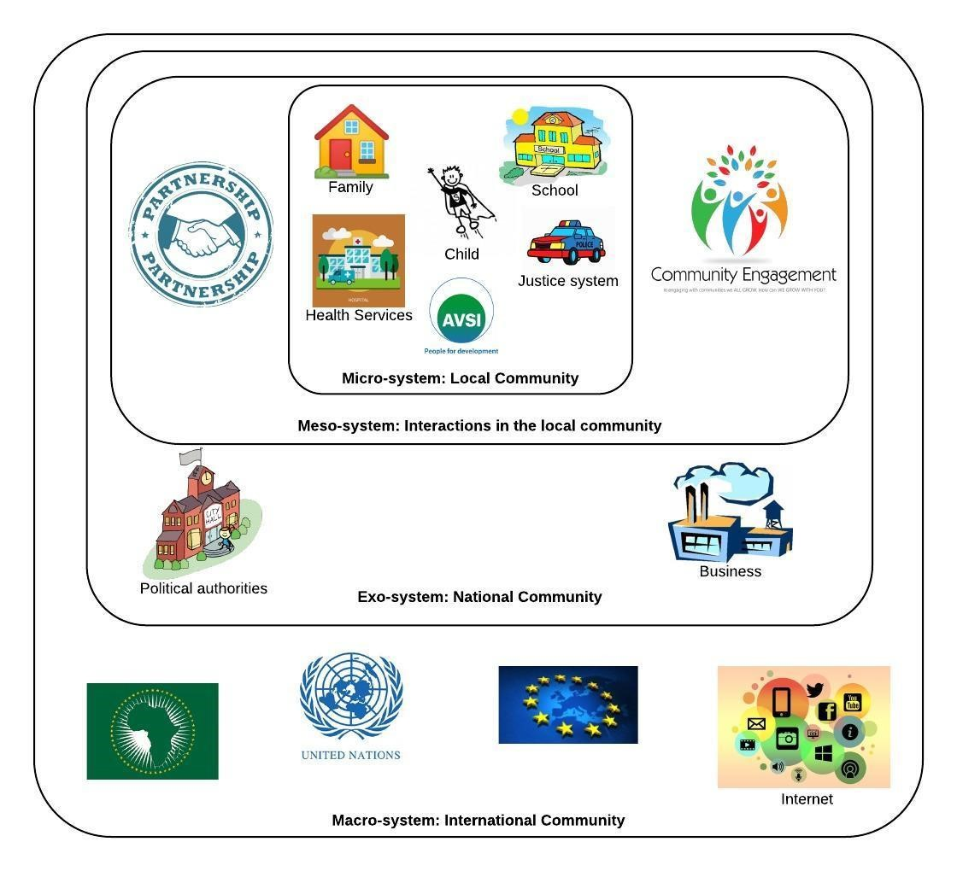

The Policy is applicable to the four systems defined by Urie Bronfenbrenner's ecological theory in which the minor is involved:

1. Micro-system: this level includes every actor who is in direct contact with the child such us family, school, the health services, the justice system, the social services, etc. Here is located AVSI.
2. Meso-system: it is the interaction level between the actors of the micro-system. It is possible to find the community engagement and the partnership between AVSI and other important stakeholders.
3. Exo-system: it is the National level, for those actors who do not interact directly with children but can influence their lives as well, e.g. political authorities and businesses.
4. Macro-system: it is the International Level which includes everything that goes beyond the border of a single country. In this space there are all the international organizations which set up strategies and policies for children as well as the global community of Internet users.

The strategy of the Implementation Plan is cross-cutting the four systems. Each strategical level has particular actions:

|  |  |  |  |  |  |  |  |  |  |  |  |  |  |  |  |  |  |  |  |  |  |  |  |
| --- | --- | --- | --- | --- | --- | --- | --- | --- | --- | --- | --- | --- | --- | --- | --- | --- | --- | --- | --- | --- | --- | --- | --- |
| |  | | --- | | **STRATEGY** | | 1. Prevention | | 2. Reporting | | 3. Responding | | 4. Evaluation | |  | |  |  | | --- | --- | |  | **ACTIONS** | | - | Risk assessment | | - | Risk mitigation | | - | Raising awareness and communication | | - | Governance and reporting structure | | - | Responding process | | - | Review of the implementation | | - | Review of the policy | |

In every AVSI country office, these actions are going to be implemented by three departments:

* Human Resources
* Communication and Advocacy
* Project Management and Research

## 1. Prevention

### 1.1 Risk assessment

It is fundamental to build a safe environment when children are the beneficiaries of a project. This can be done through different interventions such as parents and caregivers support, capacity building of social workers, strengthening of social services for children and families, creation of safe spaces for educational and recreational activities, etc.

The Child Safeguarding Risk Assessment is a part of AVSI employees’ duties towards beneficiaries in different projects. The attention is not only addressed to AVSI staff but also to the partners and the community involved in the implementation of the specific project. For every project that involves children, AVSI staff must conduct a risk assessment and evaluate with the Child Safeguarding Referral Point (CS Referral Point) (point 2.1) the possibility to mitigate the risks.

The responsible for the Child Safeguarding Risk Assessment is the Project Manager of each project who will report to the CS Referral Point to follow up on actions. The Child Safeguarding Risk Assessment tool (Annex II) is filled at the beginning of a new project.

### 1.2 Risk mitigation

The Human Resource Office (HR), both at HQ and country level, has an essential role in the internal risk mitigation. In particular they should implement specific actions during staff recruitment, training and monitoring.

Recruitment

AVSI strives to undertake due diligence in recruitment and vetting procedures to assess candidates’ and consultants’ suitability for working with children and their understanding of child protection. This ensures that every recruited person has no criminal convictions relating to children and that he/she understands and commits to the zero-tolerance for sexual exploitation, abuse and harassment as well as any type of unethical behavior.

The following guidelines should be followed when undertaking recruitment: a. The job advert should refer to AVSI’s Policy and screening process.

1. Checks, such as verification of identity and criminal records of the person with the tools available in each country should be carried out.
2. Verification that the provided references are genuine. An explicit request must be done to the referees so they can confirm there are no child protection concerns related to the candidate in exam.
3. During the interview process, the HR staff should pay attention to the candidate statements and behavior towards children.

Induction and Training

The induction and training process for all new recruited staff includes the explanation of this Policy with regards to Child Safeguarding principles, standards, and procedures for dealing with cases of concern.

AVSI ensures that the Board, management and staff, both and the HQ and in the field, have undergone an induction training on Child Safeguarding Policy and that they will receive a refresher session every time the Policy is reviewed (point 4.1).

All staff and partners must read, affirm to have understood and commit to respect the Policy, by signing Annex V.

Monitoring and appraisal system

As consequence of the training, the HR office in each country integrates into the existing monitoring and performance appraisal systems some indicators on the Policy to ensure that every employee is monitored and evaluated on those principles.

### 1.3 Raising awareness and communication

It is important to implement a series of awareness raising actions within the community and among the partners' staff on the principles of child protection as well as a special attention is addressed not to expose children to possible risks. For this reason, AVSI's Communication Office, at Headquarters level, prepares guidelines for communication on social media and other media including the following rules:

Pictures

* The informed consent of the child andparent/guardian should always be obtained before a photograph or image of a child is taken and used, and its intended and/or possible use(s) explained. Where photographs are being taken at a planned event, as far as possible individuals should be told in advance that cameras will be used and how the photos will be used, in order that they can opt out of the event or notify organizers that they do not wish to be featured in any photographs.
* Use names and images of children, young people or vulnerable adults which are respectful and not expose them to further vulnerability. Personal information about a child (such as full name and date of birth or full names of family members) and information that could identify his/her specific location within a country (such as village or community names, school, parish, etc.) should not be used, unless for specific actions which require an open and signed consent by the parents/guardians and the child.
* Children that have experienced violence, exploitation, have been otherwise abused or are in some way particularly vulnerable or at risk if identified, must not have their faces displayed or in any other way be represented in a way that may lead to their identification. In addition, their real names must be changed, and this change be indicated.

Independent photographers and writers commissioned by AVSI are considered as contractors/consultants and as such are subject to the same rules.

Data protection

* All images and stories, along with accompanying details of individuals, should be used and kept according to relevant data and privacy laws.
* Everyone who works with children’s data must protect them accordingly to the privacy law and store them in a safe place (e.g. lockable safe/ cabinet, electronic files password protected, limited access etc.), avoiding sharing information without permission.
* Before any data of a child is taken and used, the informed and written consent of the parent/guardian should always be obtained. Where caregivers are illiterate, the form has to be discussed with staff members/social services.
* When a project includes research activities, which involve children, besides the parental consent form, it is fundamental to take every measure to prevent harm. Specific guidelines should be developed for the interviews, focus groups or observations.

The general privacy guideline of AVSI can be read at the following link [https://www.avsi.org/en/privacy/.](https://www.avsi.org/en/privacy/)

## 2. Reporting

All AVSI staff members, partners, trainees, donors, sponsors, volunteers, consultants and visitors are responsible for reporting any or all suspected child abuse by following the guidelines of this Policy. Every AVSI country office should designate a CS Referral Point, who is responsible for the implementation of this policy and is the referent for the concerns’ reporting. The CS Referral Point can be supported in its duties by a Safeguarding Committee, chosen among AVSI employees.

The process of reporting and response of any safeguarding issue, from the organization staff or from a person outside the organization is described in Annex III using the form in Annex IV. The process is carried out in an independent and confidential way, while protecting both the alleged victim and the alleged perpetrator. Where the allegation is against the CS Referral Point, the report shall be made to the Country Representative; and in case the allegation is against the Country Representative it shall be reported directly to the Regional Manager.

Information on how to reach the CS Referral Point and the Safeguarding Committee should be shared also among the beneficiaries whom AVSI is working with so that they can have the opportunity to report any suspicions of abuse.

All cases will be recorded, in accordance with the privacy guidelines, and data will be used to fill an annual report (point 4.1).

## 3. Responding

The process to be followed to respond to every case of concern is different if the suspected perpetrator is an organization staff or a person from outside the organization. It implies three phases: report, investigation, action and follow-up (see Annex III).

It is important to underline that AVSI investigates every concern in collaboration to local authorities, the justice system and other organizations that can help for specific issues, for examples psychological or health assistance. Confidentiality will be kept along the process and information will be shared only with those individuals with a justifiable need to know.

For every case, the CS Referral Point should write a report, which is stored in a safe place to maintain privacy.

Breaches may incur sanctions including disciplinary action leading to possible dismissal, termination of all relations including contractual and partnership agreements, and where relevant, appropriate legal or other such actions.

If a legitimate concern about the suspected abuse of a child or young person is raised but proves to be unfounded on investigation, no action will be taken against the reporter. However, appropriate sanctions will be applied in cases of false and malicious accusations.

Since this Policy is an extension of the provision set forth in the Code of Ethics, any violation has to be considered as a breach of the Code. Compliance with the Code of Ethics is part of the contractual obligations for anyone who works with AVSI. The Code of Ethics can be downloaded from the website [www.avsi.org](http://www.avsi.org/)

Violations of the Policy constitute disciplinary and/or contractual violations that could result in dismissal, termination of all relationships, including contractual and partnership agreements, and may lead to legal or other action.

The reporting process can also be carried out correctly by following the indications contained in the DIGE 4/2018 - Whistleblowing Policy and related annexes. The "Whistleblowing Policy" reporting form is available on the website: <https://www.avsi.org/doc/227/7ff76d665c1442cfb4edb80d60136a3d/> Confirmed violations of the Code of Ethics must be reported by the Country Representative in writing to the Supervisory Authority at the following address:

Organismo di Vigilanza D.Lgs. 231

Fondazione AVSI; Via Donatello 5/B

20131 Milan - Italy

or by e-mail to: organismodivigilanza@avsi.org

## 4. Evaluation

### 4.1 Review of the implementation process

At the end of each year the HR Office, in collaboration with the CS Referral Point, has the responsibility to send to the HQ Child Protection Focal Point an annual report, which tracks the reported cases and the training activities.

The HQ Child Protection Focal Point is in charge of reports’ evaluation and provision of an improvement plan if needed.

### 4.2 Review of the policy

Every 3 years - or before if some special issue arises - the HQ Child Safeguarding Focal Point is expected to revise the policy and the implementation plan and let the new version approved by the Board of Directors.

# Annexes

# *Annex I. Definitions*

**Abuse**

A deliberate act with actual or potential negative effects upon a child’s safety, well-being, dignity, and development. It is an act that takes place in the context of a relationship of responsibility, trust, or power. (The Alliance, 2019)

**Best interests of the child**

The right of the child to have his or her best interests assessed and taken as a primary consideration in reaching a decision. It refers to the well-being of a child and is determined by a variety of individual circumstances (age, level of maturity, the presence or absence of parents, the child’s environment and experiences). (The Alliance, 2019)

**Caregiver**

An individual, community, or institution (including the State) with clear responsibility (by custom or by law) for the well-being of the child. It most often refers to a person with whom the child lives and who provides daily care to the child. (The Alliance, 2019)

**Child**

Any person under the age of 18 years.

**Child** **safeguarding**

All of the actions an organization takes to keep all children they come into contact with safe – and includes the proactive measures put in place to ensure children do not come to harm as a result of any direct or indirect contact with the company. Child safeguarding encompasses the prevention of physical, sexual and emotional abuse, neglect and maltreatment of children by employees and other persons whom the company is responsible for, including contractors, business partners, visitors to premises and volunteers. (UNICEF, 2018)

**Confidentiality**

The obligation that information about an individual will not be disclosed or made available to unauthorized persons without prior permission. There may be limits on confidentiality for children in accordance with their best interests as well as mandatory reporting obligations. (The Alliance, 2019)

**Do no Harm**

The concept of humanitarian agencies avoiding unintended negative consequences for affected persons and not undermining communities’ capacities for peace building and reconstruction. (The Alliance, 2019)

**Inclusion**

A rights-based approach to programming, aiming to ensure all people who may be at risk of being excluded have equal access to basic services and a voice in the development and implementation of those services.(The Alliance, 2019)

**Informed assent**

The expressed willingness to participate in services. Informed assent is sought from children who are by nature or law too young to give consent, but who are old enough to understand and agree to participate in services. When obtaining informed assent, practitioners must share, in a child-friendly manner, information on: services and options available, potential risks and benefits, personal information to be collected and how it will be used, and confidentiality and its limits. (The Alliance, 2019)

**Informed consent**

Voluntary agreement of an individual who has the capacity to take a decision, who understands what they are being asked to agree to, and who exercises free choice. When obtaining informed consent, practitioners must share, in a child-friendly manner, information on: services and options available, potential risks and benefits, personal information to be collected and how it will be used, and confidentiality and its limits. (The Alliance, 2019)

**Maltreatment**

Any action, including the failure to act, that results in harm, potential for harm, or threat of harm to a child. Maltreatment is commonly used as an umbrella term for abuse and neglect. (The Alliance, 2019)

**Neglect**

The intentional or unintentional failure of a caregiver – individual, community, or institution (including the State) with clear responsibility by custom or law for the well-being of the child – to:

(a) protect a child from actual or potential harm to the child’s safety, well-being, dignity and development or (b) fulfil that child’s rights to survival, development, and well-being, when they have the capacity, ability, and resources to do so. (The Alliance, 2019)

**Non-discrimination**

The principle that unfair distinctions should not be made between children, people or communities on any grounds, including age, sex, gender, race, color, ethnicity, national or social origin, sexual orientation,

HIV status, language, civil documentation, religion, disability, health status, political or other opinion, or other status. (The Alliance, 2019)

**Risk**

For child protection, risk refers to the likelihood that violations of and threats to children’s rights will manifest and cause harm to children. (The Alliance, 2019)

**Risk assessment**

A methodology used to review a hazard, how it may cause harm, and determine the probability of occurrence of harm and the severity of that harm. In child protection, it is used to determine the nature and extent of risk by taking into account potential hazards and existing conditions of vulnerability that together could harm children and families. (The Alliance, 2019)

**Sexual violence against children**

Any form of sexual activity with a child by an adult or by another child who has power over the child.

Sexual violence includes both activities that involve body contact and those without body contact. (The Alliance, 2019)

**Violence against children**

All acts that involve the intentional use of power or verbal or physical force, threatened or actual, against a child or against a group of children that either results in or has a high likelihood of resulting in actual or potential harm to the child or children’s safety, well-being, dignity, and development. (The Alliance, 2019)

**Vulnerability**

The extent to which some people may be disproportionately affected by the disruption of their physical environment and social support mechanisms following disaster or conflict. Vulnerability is specific to each person and each situation. For child protection, vulnerability refers to individual, family, community and societal characteristics that reduce children’s ability to withstand adverse impact from violations of and threats to their rights. (The Alliance, 2019)

# *Annex II. Child Safeguarding Risk Assessment Template*

|  |  |  |  |  |  |  |  |  |
| --- | --- | --- | --- | --- | --- | --- | --- | --- |
|  |  |  | **Which adults are involved in this activity?** | | **Which adults have direct responsibility for supervising the children during this activity?** | | | |
| **Type of activity - direct or indirect** | **Relevant?**  **(Yes or**  **No)** | **Level of risk? (High,**  **Medium,**  **Low)\*** | **AVSI employees, interns or volunteers** | **AVSI partners** | **Primary or proxy caregiver** | **AVSI staff** | **AVSI partners** | **Other** |
| 1. Carrying out projects that involve children as beneficiaries |  |  |  |  |  |  |  |  |
| 2. Conducting research activities that require engagement with children |  |  |  |  |  |  |  |  |
| 3. Interacting with children who live nearby AVSI office |  |  |  |  |  |  |  |  |
| 4. Providing care for children |  |  |  |  |  |  |  |  |
| 5. Working in places where child sexual exploitation is a concern |  |  |  |  |  |  |  |  |
| 6. Sharing children's data through online platforms |  |  |  |  |  |  |  |  |
| 7. Having access to child sensitive data |  |  |  |  |  |  |  |  |
| 8. Other |  |  |  |  |  |  |  |  |

\***High:** Highly likely to happen and significant impact on child.

**Medium:** Either highly likely to happen or significant impact on child.

**Low:** Less likely to happen and less of an impact on child

# *Annex III. Instructions for reporting and responding to a case of concern*

**The reporting concerns**

A possible abuse of a child

A possible abuse of a child

from the organization staff*

from a person from outside

AVSI

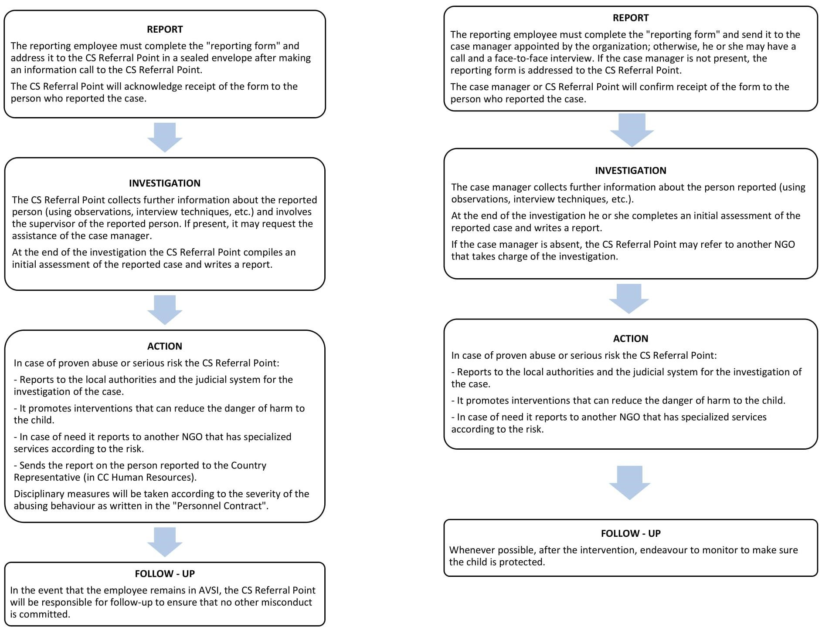

* Each person having any kind of contract with AVSI (fixed term, long term, contract of consultancy, volunteer…) is part of the organization staff.

# *Annex IV. Report form for a case of concern*

**CODE:** *…………………………………………………………*

|  |  |  |  |  |  |  |
| --- | --- | --- | --- | --- | --- | --- |
| **Information about the child** | |  | | | |  |
| Name of the child: |  | | | | | |
| Date of the child’s birth: | *(dd /mm/yyyy)* | | | | | |
| Child’s gender and nationality: | M F □ □ | | | | | |
| Child’s level and cycle: |  | | | | | |
| Child mother’s name: |  | | | | | |
| Child father’s name: |  | | | | | |
| Phone number: |  | | | | | |
| Detailed Address: |  | | | | | |
| Location of the identified child: | school □ | | AVSI’s center □ | | | |
| other location □ | | Family house □ | | | |
| Name and address of the location: |  | | | | | |
| **Information about the identification and report mechanism** | | | | | | |
| Person who identified the child: name and details | *………………………………………………………………………………………*  □ AVSI’s staff □ Partner’s staff    Role: | | | | | |
| Project and activity in which the child was identified: |  | | | | | |
| Name of the person who is filling this form: |  | | | | | |
| Date of this form compilation: | *(dd /mm/yyyy)* | | | | | |
| **Information about the report’s subject** | | | |  |  | |
| Indicators that can show a possible case of abuse: | | | | | | |
|  | | | | | | |

# *Annex V. Signatories to the AVSI Child Safeguarding Policy*

1. The AVSI Child Safeguarding Policy, signed for and on behalf of AVSI Foundation:

Name: ______________**__________________** Signature _____________________ Date __________

Designation: **Country Representative**

1. Signed by AVSI employee/collaborator/partner

I, ___________________________________ hereby append my signature to, irrevocably and unconditionally agree to the terms and conditions set out in the AVSI Child Protection Policy which I have read, understood and I commit to respect it.

Signature _________________________________ Date _______________

# Resources

Department of Foreign Affairs and Trade (DFAT)*, Child Protection Policy for the Australian Government’s aid program,* 2018.

Keeping Children Safe, *Keeping Children Safe Standards*, 2014.

The Alliance for Child Protection in Humanitarian Action, *Minimum Standards for Child Protection in Humanitarian Action, 2019 Edition*, 2019.

UNCRC, *Convention on the Rights of the Child*,1989.

UNICEF, *Child safeguarding toolkit for business*, 2018.

WHO, *World Report on Violence and Health*, 1999 & 2002.

Resilience Onlus & AVSI Foundation, *Psychosocial Approach Manual*, 2016.

This policy is inspired by other child safeguarding policies such as CAFOD, Caritas, CBM, Cesvi, COE, HDF, JRS, OAK Foundation, OVS, Oxfam, Save the Children, Sefton CVS, Plan International, Terre des Hommes.